

**PROTOCOL**to exercise

***Standing Waves***

|  |  |  |
| --- | --- | --- |
| Class | Secretary | Signature |
| **4BHELS** | **HOFSTÄTTER A.** |  |
| Exercise- / Delivery date | Employee | Signature |
| 25th February 2015  4th March 2015 |  |  |
| Teacher | Employee | Signature |
| GRASINGER |  |  |
| Grade | **Employee** | Signature |
|  |  |  |
| ***Standing Waves*** | | |
| **Used Devices**   |  |  |  |  |  | | --- | --- | --- | --- | --- | | Nr. | Device | Manufacturer | Type |  | | 1. | **Oscilloscope** | **-** |  |  | | 2. | **Function generator** | **-** |  |  | | 3. | **Spectrum Analyser** |  |  |  | | | |

Inhalt

2 Tasks 3

2.1 General Information 3

2.2 Given Exercises 3

3 Measuring of the frequency 4

4 Measuring of the wavelength 5

5 Propagation Speed 5

6 Comparison with the speed of light 5

6.1 Shortening factor 5

7 List of figures 6

# Tasks

## General Information

A configuration with two parallel lines to measure standing waves and their wavelength is also called lecher-line. At one end of the lecher-line a high frequency signal is feed into the line. On the other End of the lecher-line a short circuit was made.

The maximas of the current are always located at the distance of $λ/2$ and $λ$, measured from the short circuited lecher-line end. In addition a current maxima is also located at each end of the lecher-line.

This effect causes the possibility to measure the wavelength of a periodic signal with a lecher-line.

The practical uses of this is to measure propagation speeds of electromagnetic signals.

## Given Exercises

* Measuring of the wavelength of a radio signal using the lecher-line.
* Measuring of the frequency of the radio signal.
* Calculating of the propagation speed of the signal on the lecher-line.
* Comparison with the measured propagation speed and the speed of light in vacuum.
* Calculating of the shortening factor ($k$).

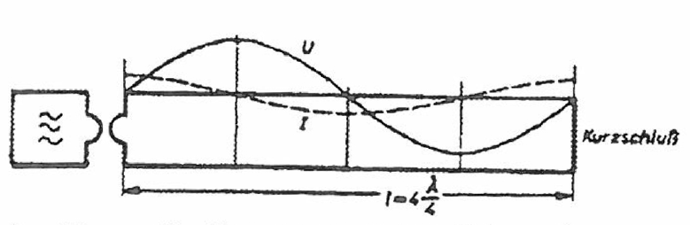

Figure 1. – Idea of the lecher-line

The given lecher-line was driven by a generator und built up on a wood-bar. Therefore the propagation speed is way smaller as the one from light.

# Measuring of the frequency

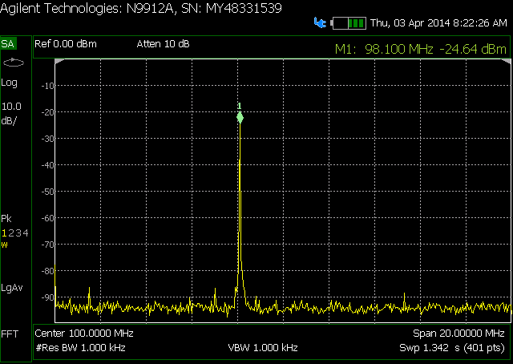

Figure 2. – Measured spectrum of the generator

The generated signal was measured on a Spectrum RF Analyser. Based on aboves spectrum it is shown that the generator has an output of about 100 MHz (exactly 98 MHz).

$$f=98 MHz$$

Measuring the signal with an oscilloscope was logically resulting in the same frequency value.

# Measuring of the wavelength

The distance between the maxima was 2,55 m. This value was measured with a light bulb connected to both lines of the lecher-line which indicated the maxima.

$$λ/2=1,275 m$$

$$λ=2,55m$$

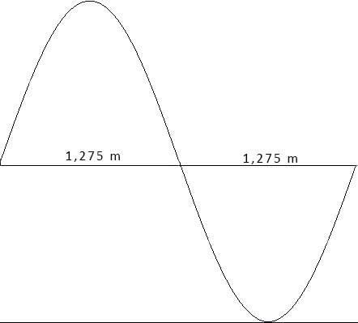

Figure 3. – Signal wavelength

# Propagation Speed

Based on both aboves measured values the propagation speed ($v$) was calculated.

$$v=λ*f=2,55m*98 MHz$$

$$v=255 000 km/s$$

# Comparison with the speed of light

The speed of light is about $3 000 000 km/s$ the measured speed with $255 000 km/s$ was therefore only 85 % of the speed of light.

## Shortening factor

Based on the measured propagation speed and the speed of the light the following calculation was made.

$$k=\frac{v}{c}=\frac{3 000 000 km/s}{250 000 km/s}=0,85$$

# List of figures

Figure 1. – Idea of the lecher-line 3

Figure 2. – Measured spectrum of the generator 4

Figure 3. – Signal wavelength 5